Project Design Phase-II
Data Flow Diagram & User Stories

Date | 06 July 2026
Team ID | SWTID-20264431
Project Name | Strategic Product Placement Analysis

Data Flow Diagrams:
A Data Flow Diagram (DFD) is a traditional visual representation of the information flows within a system. A neat and clear DFD can depict the right amount of the system requirement graphically. It shows how data enters and leaves the system, what changes the information, and where data is stored.

0 Level Data Flow Diagram :
Strategic Product Placement Analysis – Tableau Dashboard 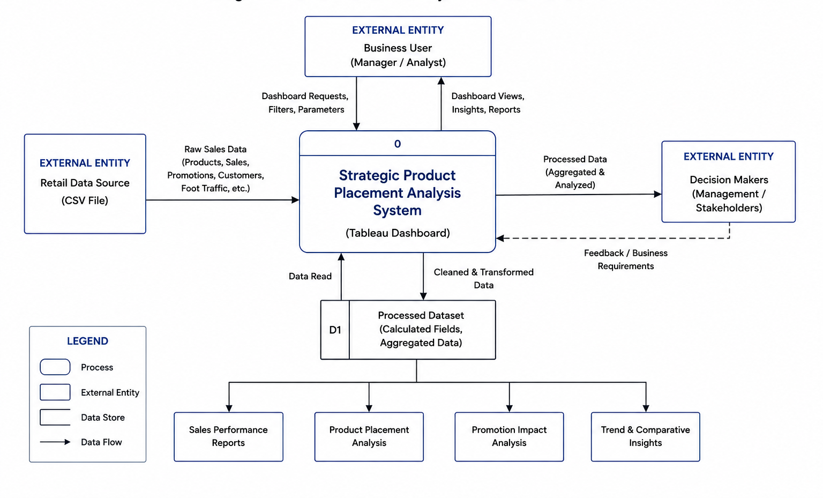 User Stories :

User Type | Functional Requirement (Epic) | User Story Number | User Story / Task | Acceptance Criteria | Priority | Release
Data Analyst | Data Rendering | USN-1 | import the Retail Sales Dataset into Tableau Public for analysis. | The dataset is successfully imported and all records are displayed correctly. | High | Sprint-1
Data Analyst | Data Preprocessing | USN-2 | validate field names, data types, and remove inconsistencies before visualization. | The dataset is clean, consistent, and ready for analysis. | High | Sprint-1
Business Analyst | Interactive Filters | USN-3 | filter the dashboard by Product Position, Product Category, and Consumer Demographics. | Dashboard updates dynamically based on selected filters. | High | Sprint-2
Business Analyst | Calculated Fields | USN-4 | create calculated fields for Price, Competitor Price, and Sales Volume analysis. | Calculated fields produce accurate values without errors. | High | Sprint-2
Retail Manager | Sales Analysis | USN-5 | analyze Average Sales Volume by Product Category using a Horizontal Bar Chart. | The chart correctly compares average sales volume across product categories. | High | Sprint-2
Marketing Manager | Promotion Analysis | USN-6 | analyze the relationship between Promotion, Price, and Sales Volume using a Text Table. | Promotion performance is displayed accurately. | Medium | Sprint-2
Sales Manager | Customer Analysis | USN-7 | analyze Consumer Demographics versus Average Sales Volume using a Donut Chart. | The donut chart correctly represents customer demographic distribution. | Medium | Sprint-2
Store Manager | Product Placement Analysis | USN-8 | analyze Product Category and Product Position using a Tree map. | The tree map displays product placement performance correctly. | High | Sprint-2
Sales Manager | Traffic & Pricing Analysis | USN-9 | to analyze Foot Traffic, Product Price, and Competitor Price using Packed Bubble and Clustered Bar Charts. | The visualizations accurately represent traffic and pricing analysis. | Medium | Sprint-2
Business Manager | Seasonal Performance Analysis | USN-10 | to analyze seasonal sales performance and product pricing using Stacked Bar and Pie Charts. | Seasonal trends and price distribution are displayed correctly. | Medium | Sprint-2
Decision Maker | Dashboard Design | USN-11 | an interactive Tableau dashboard with eight visualizations to explore business insights efficiently. | All visualizations load correctly, filters function properly, and the dashboard performs smoothly. | High | Sprint-2
Decision Maker | Story Design | USN-12 | Tableau Story that presents key business insights through three story points. | All story points display correctly and navigation works without errors. | High | Sprint-2

